The submission of reports, forms, responses, and other information via ACCSC’s College 360 Database facilitates a more efficient collection and dissemination of school information. Therefore, the Commission requires the submission of all forms and reports to be prepared in accordance with the requirements set forth in these instructions and submitted via ACCSC’s College 360 Database.

SUBMISSION FORMAT REQUIREMENTS:
- ACCSC will not accept any electronic submission transmitted to the Commission via e-mail.
- Document submissions must be prepared in accordance with the checklist requirements listed within this document.
- All documents must be submitted to ACCSC as one Portable Document Format (“PDF”) file that has been prepared using Adobe Acrobat software (version 8.0 or higher) and which has a .pdf extension as part of the file name.
- All PDF documents must be submitted via upload to the School Submission Center on ACCSC’s College 360 Database. ACCSC’s College 360 Database can be accessed by clicking here. Please note that the password to the School Submission Center in the College360 Database is the same as that used by institutions to access the Annual Report Portal. Detailed directions for uploading a school submission can be found here.
- An acceptable PDF file is one that includes the compilation of all of the materials and documents into one single file and not a series of separate files. All documents are to be submitted as one continuous PDF document using the Adobe Acrobat software. Only PDF files will be accepted. ACCSC will not accept files in other formats such as Microsoft Word, Excel, or PowerPoint; Word Perfect; TIFF; JPEG; etc.
- All PDF documents must include electronic bookmarks and hyperlinks placed within the document in order to identify all of the attachments and exhibits contained within the file. Bookmarking and hyperlinking should be done in a manner that facilitates an easy and intuitive navigation and review of the file. For example:
a. Clearly label each bookmark so the reader will easily understand to which document or exhibit the bookmark will take the reader;
b. Bookmark each document that has been compiled into the PDF (e.g., include bookmarks for the Team Summary Report and the school’s response);
c. In a response to an on-site evaluation report or a Commission action letter, bookmark each Team Finding or Commission action letter item and also bookmark the school’s narrative response to each item – this is a good place to use sub-level bookmarks;
d. Bookmark and label all exhibits; and
e. Where appropriate, use the Adobe link tool to create a dynamic hyperlink from the narrative response to a specific location or document in the file (e.g., to the specific exhibit that supports that section of the narrative response). See page three of these instructions for a sample view of bookmarks and hyperlinks.
- Whenever possible, directly convert documents to PDF as opposed to scanning and creating PDFs from paper documents. The direct conversion of documents to a PDF format allows for far greater readability. For example, complete the narrative response using word processing software (e.g., MS Word), convert the Word document directly to a PDF file, and then combine the converted file with other converted or scanned documents into a single PDF document.
- Any security features in the PDF document must be disabled.
- All document submissions must contain a cover letter that includes the school name, address, ACCSC school number, and an explanation of the content and the title of the document(s) included on medium.
- If the document submission contains documentation that includes personal or confidential student or staff information that is not required for the Commission’s review (e.g., social security numbers, dates of birth, etc.), please remove or redact that information.
12. Any document that is submitted not in accordance with these instructions will not be processed. If the document is one required by the Commission to be submitted by an assigned due date, the school will be charged a late fee.
13. If a fee is required for the processing of an application, please mail a check directly to ACCSC for processing and include a statement identifying the corresponding application(s). Please note that applications which require a payment will not be processed until the corresponding fee is sent:

ACCSC
2101 Wilson Boulevard
Suite 302
Arlington, Virginia 22201

School Submission Upload Checklist
The uploaded submission must include the following:
- A cover letter identifying the institution by name, address, ACCSC school number; an explanation of the content and the title of the document(s); and a name, phone number, and e-mail address for a point of contact at the school for questions regarding the submission.
- A bookmarked Table of Contents.
- A copy of the Commission letter and the school’s response to the Commission letter compiled into one PDF file.
- A signed Certification Statement attesting to the accuracy of the data contained in the response.
- An introduction with instructions on how to navigate the document.
- A restatement of each item listed in the Commission letter/report/enclosure followed by the school’s narrative response with electronic bookmarks to indicate the location of the response and all pertinent information and documentation.
- Schools must submit a narrative response for each and every item in the Commission’s letter/report/enclosure.
- Documentation to support the narrative response, including any exhibits, with electronic bookmarks and hyperlinks to indicate the location of the documentation.
- If a fee is required for the processing of an application, please mail a check directly to ACCSC for processing and include a statement identifying the corresponding application(s).

Sample View of an Appropriately Prepared Electronic Submission

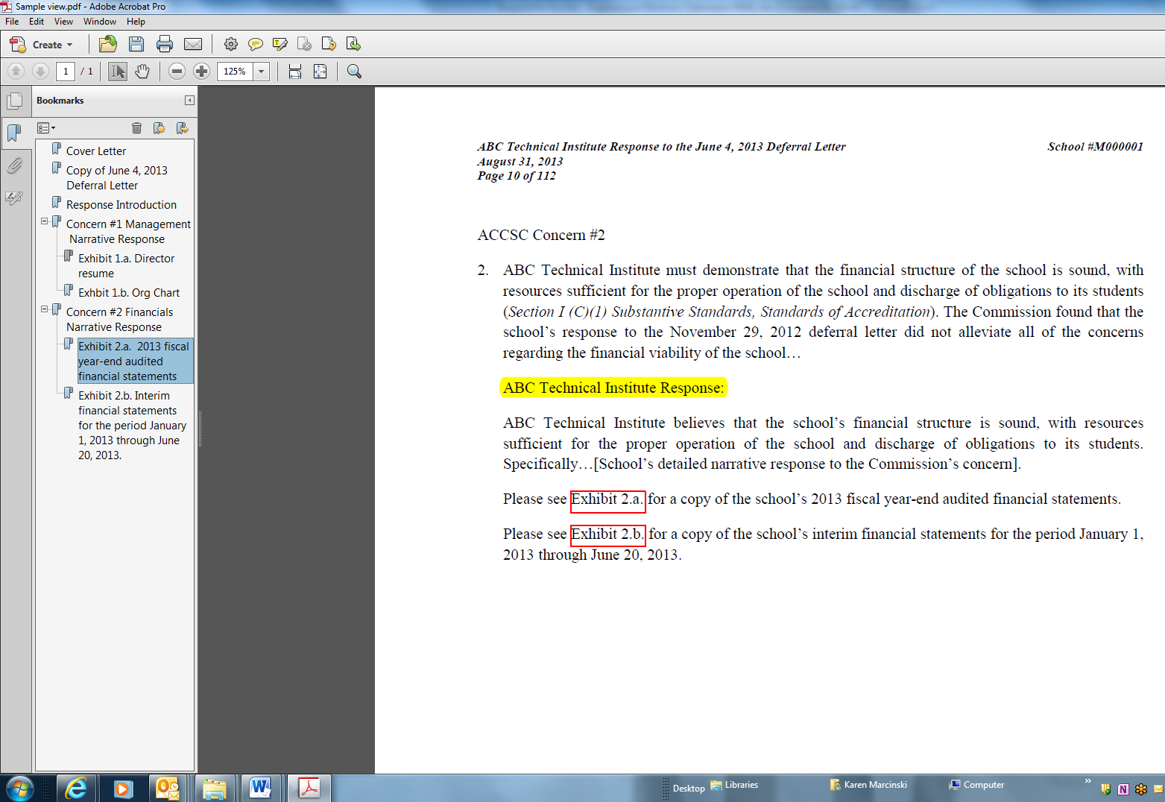
Sub-Level Bookmark
Hyperlink to Exhibit 2b
Restatement of Concern
Narrative Response
Bookmarks

For initial applicants: upon receipt of the Application for Initial Accreditation-Part I, ACCSC will assign the school a six-digit school number to be included on all future submissions to be considered by the Commission.

