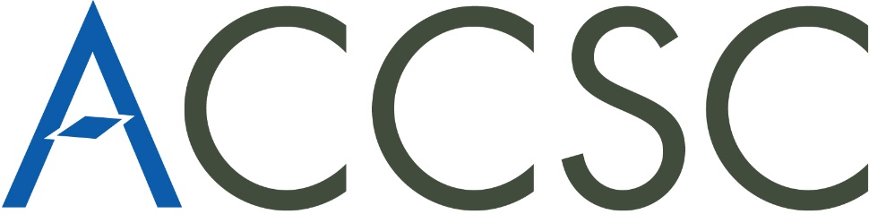

Certificate of Attendance

This certifies that

«First» «Last»
«School»
«City»

Has attended an official program of professional development at the

#MeToo: Title IX for Non-Traditional Schools

An ACCSC Authorized Webinar

