**TYPING ACCESSIBILITY**

ACCSC requires written submissions for many areas of the accreditation process. Should you require dictation/transcription assistance, the following utilities are available:

* Microsoft Dictation/Transcription
* MacOS Dictation
* Google Docs Voice Typing in Google Chrome

For **Microsoft Windows** users with access to Microsoft Word and a microphone, Dictate and Transcribe are available on the Home ribbon:

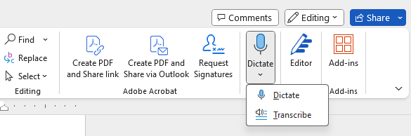

Link to Microsoft guide to dictation and computer control via voice: <https://support.microsoft.com/en-us/topic/dictate-text-with-voice-4ddaf335-a835-4e63-9a30-e24b9f361deb>

Link to Microsoft guide to transcription (upload an audio file or start recording): <https://support.microsoft.com/en-us/office/transcribe-your-recordings-7fc2efec-245e-45f0-b053-2a97531ecf57>

For **MacOS** users:

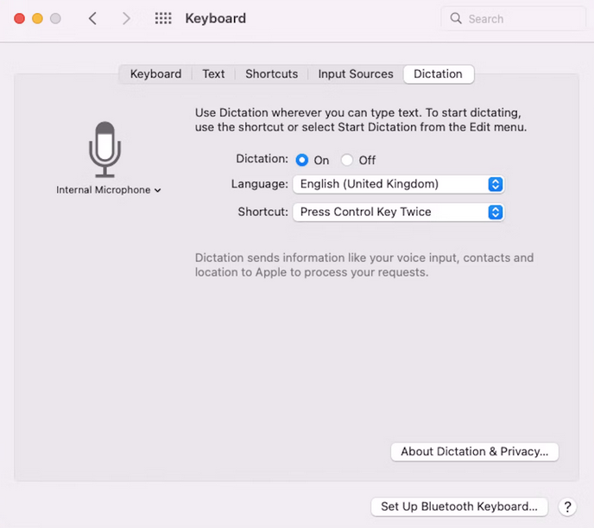

Link to Apple support on how to dictate messages and documents on Mac: <https://support.apple.com/guide/mac-help/use-dictation-mh40584/mac>

For **Google** users, Google Docs Voice typing in Google Chrome:

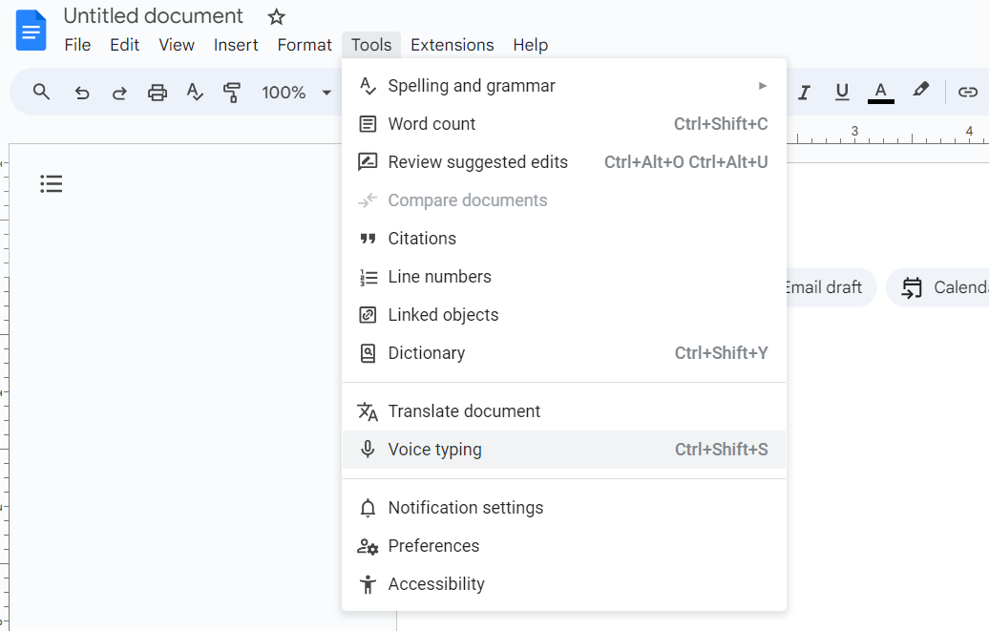

Link to Google support on how to start voice typing in a document/Use voice commands: <https://support.google.com/docs/answer/4492226?hl=en#zippy=%2Ctype-with-your-voice>